Fresh Mozzarella Caprese Skewers

1 package (8 oz.) Culinary Tours Fresh Mozzarella Ciliegine
24 cherry tomatoes
24 fresh basil leaves
12 (6-inch) wooden skewers
Balsamic glaze

Drain mozzarella and place on a plate lined with paper towels to dry. Alternately thread 2 mozzarella balls, 2 cherry tomatoes and 2 folded basil leaves on each skewer. Arrange skewers on serving platter and drizzle with balsamic glaze. 12 servings.

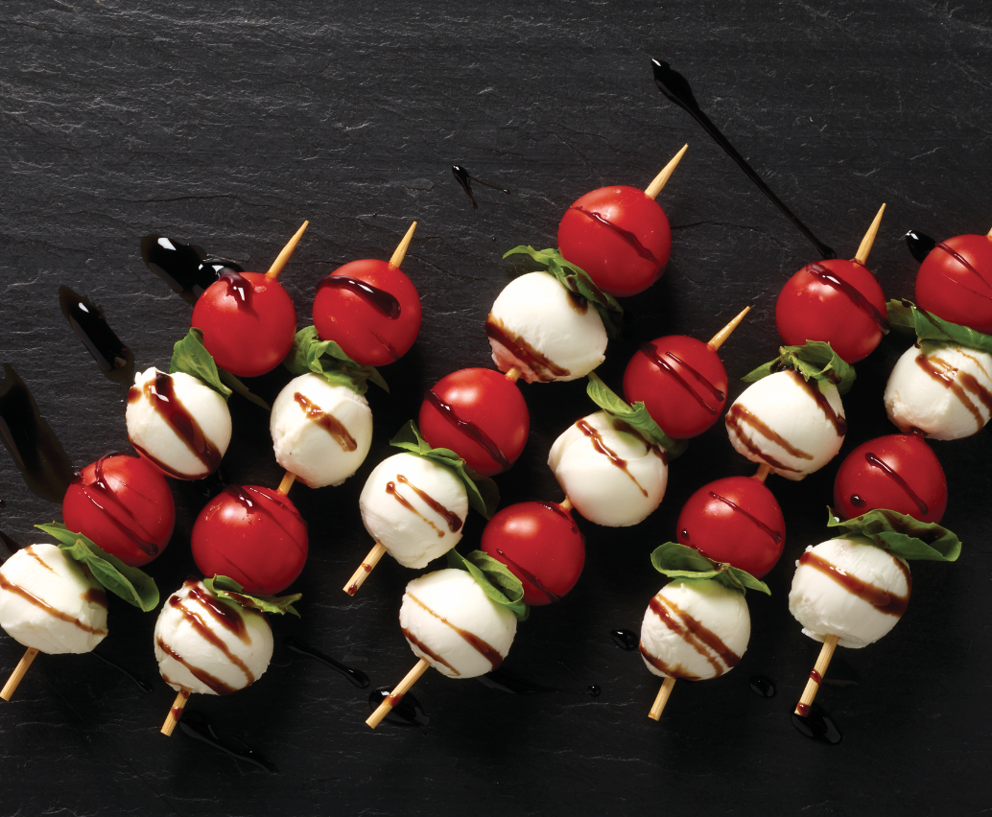

Recipe for #412953 Culinary Tours Marketing Playbook
by Becky Roller 06/19/20

